=>Go to
https://archive.trufflesuite.com/boxes/metacoin/

- Create truffletutorial folder
- Cd truffletutorial folder
- Truffle unbox metacoin
- Truffle compile
uncomment following in truffle-config.js file
development: {
host: "127.0.0.1", // Localhost (default: none)
port: 7545, // Standard Ethereum port (default: none)
network_id: "*", // Any network (default: none)
}
- Truffle migrate

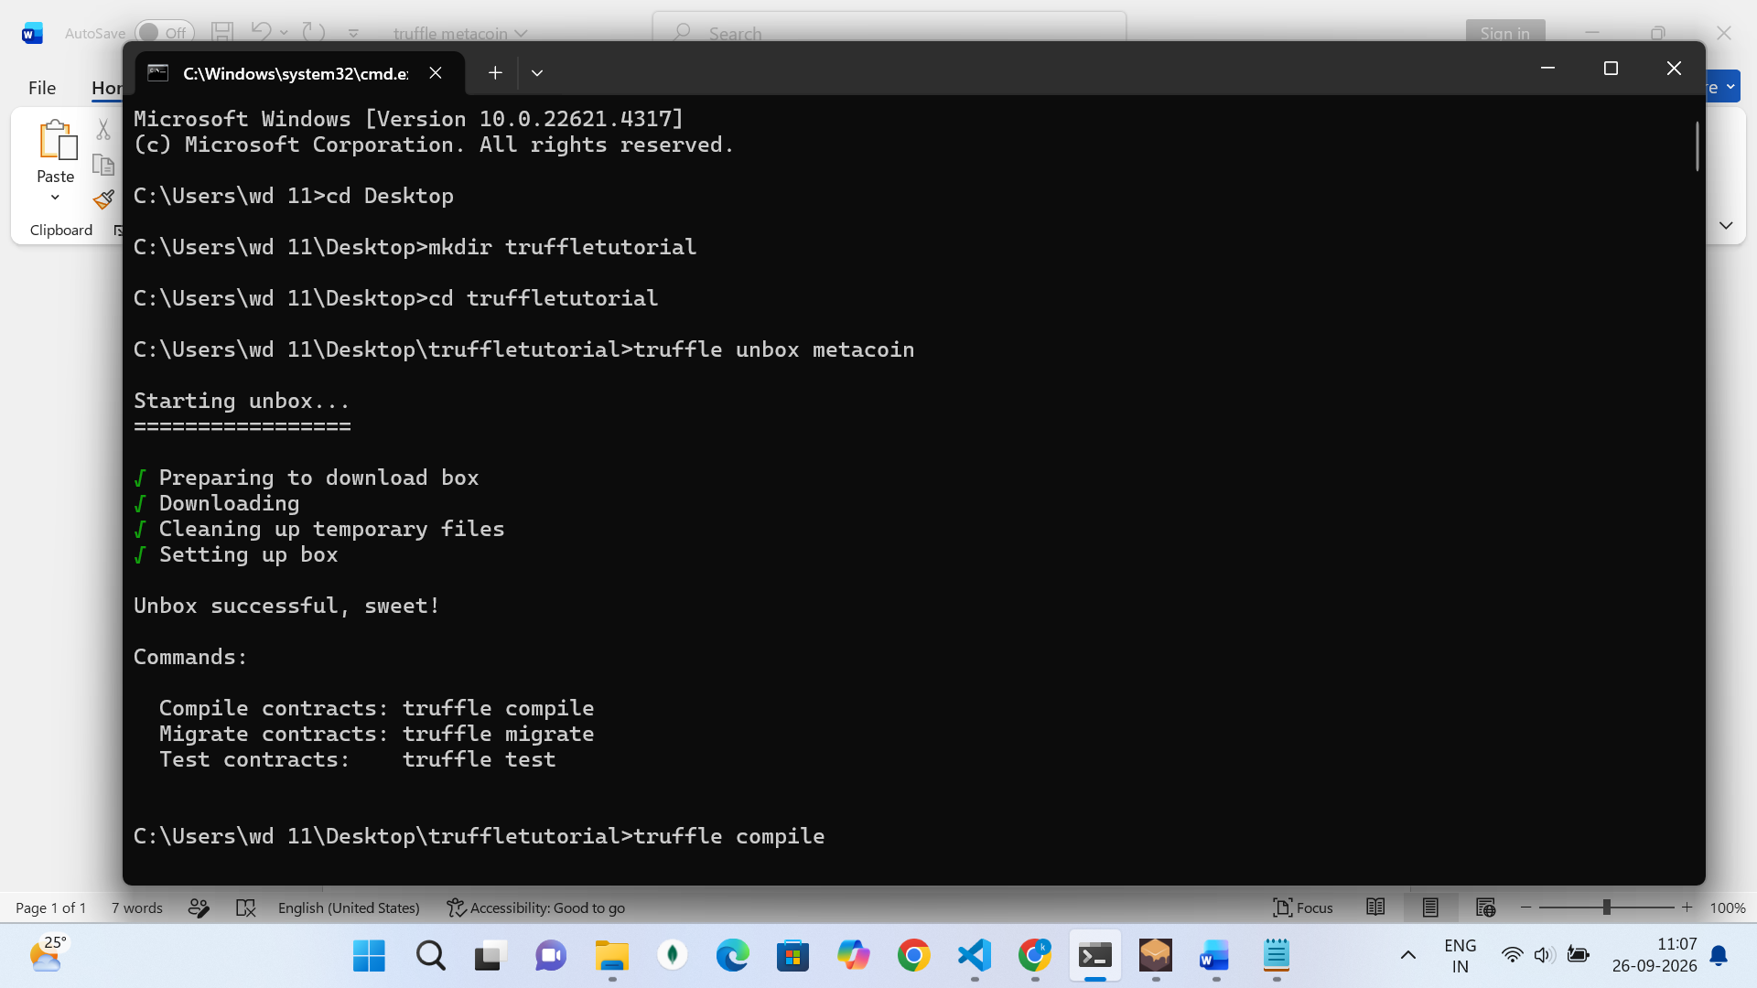

Then in your ganache you will be able to see this if everything runs successfully

